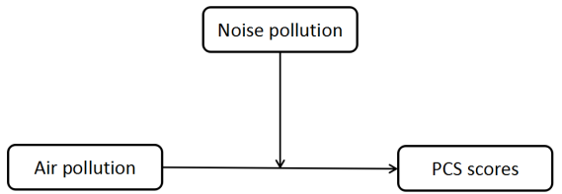
Figure 1. Conceptual diagram

Model = 1 Y = agg_phys X = air M = noise
Statistical Controls:CONTROL= empreln bmi hhdnum religion alcohg smokg
Sample size 3701

**************************************************************************
Outcome: agg_phys

Model Summary
R R-sq MSE F df1 df2 p
.3141 .0987 108.2506 41.6327 9.0000 3691.0000 .0000

Model
coeff se t p LLCI ULCI
constant 43.6188 1.4097 30.9430 .0000 40.8551 46.3826
noise 1.0257 .4335 2.3658 .0180 .1757 1.8756
air .3777 .4341 .8700 .3844 -.4735 1.2289
int_1 -1.1309 .8402 -1.3460 .1784 -2.7781 .5164
empreln -5.3164 .3938 -13.5012 .0000 -6.0885 -4.5444
bmi .1599 .0547 2.9245 .0035 .0527 .2672
hhdnum .7556 .1667 4.5339 .0000 .4288 1.0823
religion 1.4756 .5365 2.7505 .0060 .4238 2.5274
alcohg -.6854 .4088 -1.6766 .0937 -1.4868 .1161
smokg 3.4405 .3873 8.8831 .0000 2.6811 4.1998

Interactions:

int_1 air X noise

*************************************************************************

Conditional effect of X on Y at values of the moderator(s):
noise Effect se t p LLCI ULCI
-.3002 .7172 .5580 1.2851 .1988 -.3769 1.8113
.6998 -.4137 .6292 -.6575 .5109 -1.6473 .8199

**************************************************************************

Data for visualizing conditional effect of X on Y
Paste text below into a SPSS syntax window and execute to produce plot.

DATA LIST FREE/air noise agg_phys.
BEGIN DATA.

-.2907 -.3002 49.0581
.7093 -.3002 49.7752
-.2907 .6998 50.4125
.7093 .6998 49.9988

END DATA.
GRAPH/SCATTERPLOT=air WITH agg_phys BY noise.

* Estimates are based on setting covariates to their sample means.

******************** ANALYSIS NOTES AND WARNINGS *************************

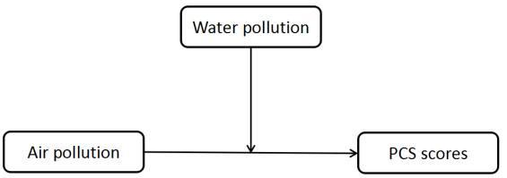

Figure 2. Conceptual diagram

Model = 1 Y = agg_phys X = air M = water
Statistical Controls:CONTROL= empreln bmi hhdnum religion alcohg smokg
Sample size 3697

**************************************************************************
Outcome: agg_phys

Model Summary
R R-sq MSE F df1 df2 p
.3159 .0998 108.0639 42.1580 9.0000 3687.0000 .0000

Model
coeff se t p LLCI ULCI
constant 43.2162 1.4080 30.6932 .0000 40.4557 45.9768
water -1.1953 .5185 -2.3055 .0212 -2.2118 -.1788
air .8871 .4426 2.0044 .0451 .0194 1.7548
int_1 1.8177 .9224 1.9706 .0488 .0092 3.6261
empreln -5.3334 .3941 -13.5340 .0000 -6.1060 -4.5607
bmi .1668 .0545 3.0626 .0022 .0600 .2735
hhdnum .7532 .1662 4.5322 .0000 .4274 1.0790
religion 1.4208 .5371 2.6453 .0082 .3678 2.4739
alcohg -.6960 .4091 -1.7012 .0890 -1.4981 .1061
smokg 3.4773 .3869 8.9869 .0000 2.7186 4.2359

Interactions:

int_1 air X water

*************************************************************************

Conditional effect of X on Y at values of the moderator(s):
water Effect se t p LLCI ULCI
-.2659 .4038 .5354 .7541 .4508 -.6460 1.4535
.7341 2.2214 .7548 2.9432 .0033 .7416 3.7012

**************************************************************************

Data for visualizing conditional effect of X on Y
Paste text below into a SPSS syntax window and execute to produce plot.

DATA LIST FREE/air water agg_phys.
BEGIN DATA.

-.2905 -.2659 49.4782
.7095 -.2659 49.8820
-.2905 .7341 47.7548
.7095 .7341 49.9763

END DATA.
GRAPH/SCATTERPLOT=air WITH agg_phys BY water.

* Estimates are based on setting covariates to their sample means.

******************** ANALYSIS NOTES AND WARNINGS *************************

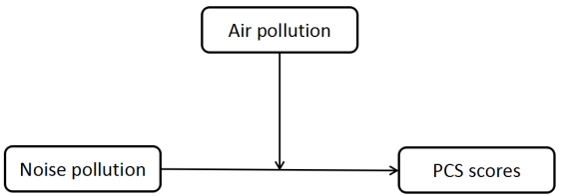
Figure 3. Conceptual diagram

Model = 1 Y = agg_phys X = noise M = air
Statistical Controls:CONTROL= empreln bmi hhdnum religion alcohg smokg
Sample size 3701

**************************************************************************
Outcome: agg_phys

Model Summary
R R-sq MSE F df1 df2 p
.3141 .0987 108.2506 41.6327 9.0000 3691.0000 .0000

Model
coeff se t p LLCI ULCI
constant 43.6188 1.4097 30.9430 .0000 40.8551 46.3826
air .3777 .4341 .8700 .3844 -.4735 1.2289
noise 1.0257 .4335 2.3658 .0180 .1757 1.8756
int_1 -1.1309 .8402 -1.3460 .1784 -2.7781 .5164
empreln -5.3164 .3938 -13.5012 .0000 -6.0885 -4.5444
bmi .1599 .0547 2.9245 .0035 .0527 .2672
hhdnum .7556 .1667 4.5339 .0000 .4288 1.0823
religion 1.4756 .5365 2.7505 .0060 .4238 2.5274
alcohg -.6854 .4088 -1.6766 .0937 -1.4868 .1161
smokg 3.4405 .3873 8.8831 .0000 2.6811 4.1998

Interactions:

int_1 noise X air

*************************************************************************

Conditional effect of X on Y at values of the moderator(s):
air Effect se t p LLCI ULCI
-.2907 1.3544 .5529 2.4498 .0143 .2705 2.4384
.7093 .2236 .6336 .3529 .7242 -1.0186 1.4658

**************************************************************************

Data for visualizing conditional effect of X on Y
Paste text below into a SPSS syntax window and execute to produce plot.

DATA LIST FREE/noise air agg_phys.
BEGIN DATA.

-.3002 -.2907 49.0581
.6998 -.2907 50.4125
-.3002 .7093 49.7752
.6998 .7093 49.9988

END DATA.
GRAPH/SCATTERPLOT=noise WITH agg_phys BY air.

* Estimates are based on setting covariates to their sample means.

******************** ANALYSIS NOTES AND WARNINGS *************************

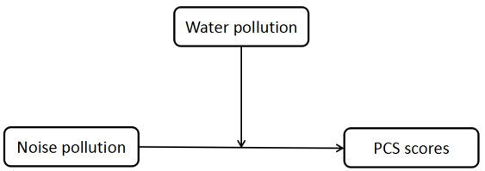

Figure 4. Conceptual diagram

Model = 1 Y = agg_phys X = noise M = water
Statistical Controls:CONTROL= empreln bmi hhdnum religion alcohg smokg
Sample size 3697

**************************************************************************
Outcome: agg_phys

Model Summary
R R-sq MSE F df1 df2 p
.3159 .0998 108.0623 42.2529 9.0000 3687.0000 .0000

Model
coeff se t p LLCI ULCI
constant 43.4136 1.4024 30.9563 .0000 40.6640 46.1632
water -.7935 .4373 -1.8146 .0697 -1.6509 .0639
noise 1.2122 .3935 3.0803 .0021 .4406 1.9838
int_1 .5199 .8289 .6272 .5306 -1.1052 2.1450
empreln -5.3598 .3941 -13.6004 .0000 -6.1325 -4.5872
bmi .1652 .0544 3.0339 .0024 .0584 .2719
hhdnum .7552 .1649 4.5790 .0000 .4318 1.0785
religion 1.4330 .5357 2.6749 .0075 .3827 2.4834
alcohg -.6985 .4094 -1.7063 .0880 -1.5011 .1041
smokg 3.4352 .3879 8.8551 .0000 2.6746 4.1958

Interactions:

int_1 noise X water

*************************************************************************

Conditional effect of X on Y at values of the moderator(s):
water Effect se t p LLCI ULCI
-.2659 1.0740 .4760 2.2565 .0241 .1408 2.0072
.7341 1.5939 .6793 2.3464 .0190 .2621 2.9257

**************************************************************************

Data for visualizing conditional effect of X on Y
Paste text below into a SPSS syntax window and execute to produce plot.

DATA LIST FREE/noise water agg_phys.
BEGIN DATA.

-.3000 -.2659 49.3177
.7000 -.2659 50.3916
-.3000 .7341 48.3682
.7000 .7341 49.9621

END DATA.
GRAPH/SCATTERPLOT=noise WITH agg_phys BY water.

* Estimates are based on setting covariates to their sample means.

******************** ANALYSIS NOTES AND WARNINGS *************************

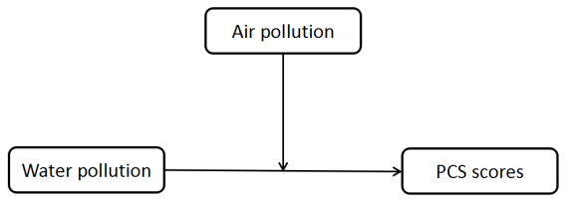
Figure 5. Conceptual diagram

Model = 1 Y = agg_phys X = water M = air
Statistical Controls:CONTROL= empreln bmi hhdnum religion alcohg smokg
Sample size 3697

**************************************************************************
Outcome: agg_phys

Model Summary
R R-sq MSE F df1 df2 p
.3159 .0998 108.0639 42.1580 9.0000 3687.0000 .0000

Model
coeff se t p LLCI ULCI
constant 43.2162 1.4080 30.6932 .0000 40.4557 45.9768
air .8871 .4426 2.0044 .0451 .0194 1.7548
water -1.1953 .5185 -2.3055 .0212 -2.2118 -.1788
int_1 1.8177 .9224 1.9706 .0488 .0092 3.6261
empreln -5.3334 .3941 -13.5340 .0000 -6.1060 -4.5607
bmi .1668 .0545 3.0626 .0022 .0600 .2735
hhdnum .7532 .1662 4.5322 .0000 .4274 1.0790
religion 1.4208 .5371 2.6453 .0082 .3678 2.4739
alcohg -.6960 .4091 -1.7012 .0890 -1.4981 .1061
smokg 3.4773 .3869 8.9869 .0000 2.7186 4.2359

Interactions:

int_1 water X air

*************************************************************************

Conditional effect of X on Y at values of the moderator(s):
air Effect se t p LLCI ULCI
-.2905 -1.7234 .6842 -2.5190 .0118 -3.0647 -.3820
.7095 .0943 .6211 .1518 .8794 -1.1235 1.3121

**************************************************************************

Data for visualizing conditional effect of X on Y
Paste text below into a SPSS syntax window and execute to produce plot.

DATA LIST FREE/water air agg_phys.
BEGIN DATA.

-.2659 -.2905 49.4782
.7341 -.2905 47.7548
-.2659 .7095 49.8820
.7341 .7095 49.9763

END DATA.
GRAPH/SCATTERPLOT=water WITH agg_phys BY air.

* Estimates are based on setting covariates to their sample means.

******************** ANALYSIS NOTES AND WARNINGS *************************

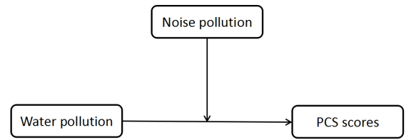
Figure 6. Conceptual diagram

Model = 1 Y = agg_phys X = water M = noise
Statistical Controls:CONTROL= empreln bmi hhdnum religion alcohg smokg
Sample size 3697

**************************************************************************
Outcome: agg_phys

Model Summary
R R-sq MSE F df1 df2 p
.3159 .0998 108.0623 42.2529 9.0000 3687.0000 .0000

Model
coeff se t p LLCI ULCI
constant 43.4136 1.4024 30.9563 .0000 40.6640 46.1632
noise 1.2122 .3935 3.0803 .0021 .4406 1.9838
water -.7935 .4373 -1.8146 .0697 -1.6509 .0639
int_1 .5199 .8289 .6272 .5306 -1.1052 2.1450
empreln -5.3598 .3941 -13.6004 .0000 -6.1325 -4.5872
bmi .1652 .0544 3.0339 .0024 .0584 .2719
hhdnum .7552 .1649 4.5790 .0000 .4318 1.0785
religion 1.4330 .5357 2.6749 .0075 .3827 2.4834
alcohg -.6985 .4094 -1.7063 .0880 -1.5011 .1041
smokg 3.4352 .3879 8.8551 .0000 2.6746 4.1958

Interactions:

int_1 water X noise

*************************************************************************

Conditional effect of X on Y at values of the moderator(s):
noise Effect se t p LLCI ULCI
-.3000 -.9495 .5688 -1.6691 .0952 -2.0647 .1658
.7000 -.4296 .6028 -.7126 .4761 -1.6114 .7523

**************************************************************************

Data for visualizing conditional effect of X on Y
Paste text below into a SPSS syntax window and execute to produce plot.

DATA LIST FREE/water noise agg_phys.
BEGIN DATA.

-.2659 -.3000 49.3177
.7341 -.3000 48.3682
-.2659 .7000 50.3916
.7341 .7000 49.9621

END DATA.
GRAPH/SCATTERPLOT=water WITH agg_phys BY noise.

* Estimates are based on setting covariates to their sample means.

******************** ANALYSIS NOTES AND WARNINGS *************************

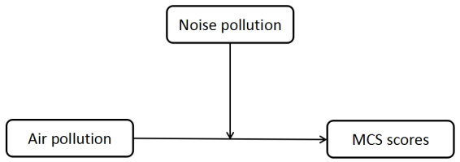
Figure 7. Conceptual diagram

Model = 1 Y = agg_ment X = air M = noise
Statistical Controls:CONTROL= empreln bmi hhdnum religion alcohg smokg
Sample size 3701

**************************************************************************
Outcome: agg_ment

Model Summary
R R-sq MSE F df1 df2 p
.1407 .0198 86.8885 8.2180 9.0000 3691.0000 .0000

Model
coeff se t p LLCI ULCI
constant 42.5094 1.2076 35.2005 .0000 40.1417 44.8771
noise -.2411 .3943 -.6115 .5409 -1.0141 .5319
air -.6997 .3964 -1.7649 .0777 -1.4769 .0776
int_1 1.1854 .7722 1.5350 .1249 -.3287 2.6994
empreln -.7567 .3379 -2.2392 .0252 -1.4192 -.0941
bmi .2526 .0465 5.4272 .0000 .1613 .3438
hhdnum -.0812 .1410 -.5759 .5647 -.3575 .1952
religion .5196 .4735 1.0975 .2725 -.4087 1.4479
alcohg .5088 .3688 1.3798 .1677 -.2142 1.2318
smokg 1.2380 .3530 3.5071 .0005 .5459 1.9301

Interactions:

int_1 air X noise

*************************************************************************

Conditional effect of X on Y at values of the moderator(s):
noise Effect se t p LLCI ULCI
-.3002 -1.0555 .5085 -2.0756 .0380 -2.0525 -.0585
.6998 .1299 .5814 .2234 .8233 -1.0100 1.2697

**************************************************************************

Data for visualizing conditional effect of X on Y
Paste text below into a SPSS syntax window and execute to produce plot.

DATA LIST FREE/air noise agg_ment.
BEGIN DATA.

-.2907 -.3002 49.1613
.7093 -.3002 48.1059
-.2907 .6998 48.5756
.7093 .6998 48.7055

END DATA.
GRAPH/SCATTERPLOT=air WITH agg_ment BY noise.

* Estimates are based on setting covariates to their sample means.

******************** ANALYSIS NOTES AND WARNINGS *************************

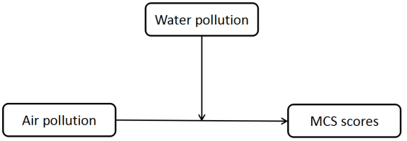
Figure 8. Conceptual diagram

Model = 1 Y = agg_ment X = air M = water
Statistical Controls:CONTROL= empreln bmi hhdnum religion alcohg smokg
Sample size 3697

**************************************************************************
Outcome: agg_ment

Model Summary
R R-sq MSE F df1 df2 p
.1406 .0198 86.7315 8.2739 9.0000 3687.0000 .0000

Model
coeff se t p LLCI ULCI
constant 42.6005 1.2095 35.2203 .0000 40.2291 44.9720
water -.6463 .4449 -1.4527 .1464 -1.5185 .2260
air -.4553 .4011 -1.1350 .2565 -1.2418 .3312
int_1 .8471 .8192 1.0341 .3012 -.7590 2.4532
empreln -.7895 .3377 -2.3378 .0194 -1.4517 -.1274
bmi .2507 .0464 5.4014 .0000 .1597 .3417
hhdnum -.0760 .1411 -.5385 .5903 -.3526 .2007
religion .4838 .4743 1.0200 .3078 -.4461 1.4137
alcohg .5310 .3695 1.4371 .1508 -.1934 1.2554
smokg 1.2159 .3522 3.4522 .0006 .5254 1.9064

Interactions:

int_1 air X water

*************************************************************************

Conditional effect of X on Y at values of the moderator(s):
water Effect se t p LLCI ULCI
-.2659 -.6805 .4908 -1.3866 .1656 -1.6428 .2817
.7341 .1666 .6579 .2532 .8001 -1.1232 1.4564

**************************************************************************

Data for visualizing conditional effect of X on Y
Paste text below into a SPSS syntax window and execute to produce plot.

DATA LIST FREE/air water agg_ment.
BEGIN DATA.

-.2905 -.2659 49.1679
.7095 -.2659 48.4874
-.2905 .7341 48.2755
.7095 .7341 48.4421

END DATA.
GRAPH/SCATTERPLOT=air WITH agg_ment BY water.

* Estimates are based on setting covariates to their sample means.

******************** ANALYSIS NOTES AND WARNINGS *************************

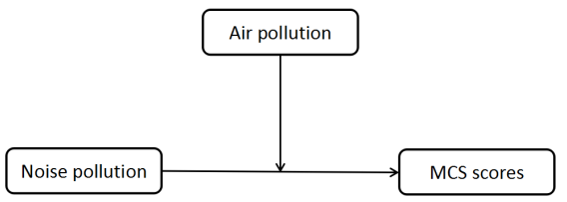
Figure 9. Conceptual diagram

Model = 1 Y = agg_ment X = noise M = air
Statistical Controls:CONTROL= empreln bmi hhdnum religion alcohg smokg
Sample size 3701

**************************************************************************
Outcome: agg_ment

Model Summary
R R-sq MSE F df1 df2 p
.1407 .0198 86.8885 8.2180 9.0000 3691.0000 .0000

Model
coeff se t p LLCI ULCI
constant 42.5094 1.2076 35.2005 .0000 40.1417 44.8771
air -.6997 .3964 -1.7649 .0777 -1.4769 .0776
noise -.2411 .3943 -.6115 .5409 -1.0141 .5319
int_1 1.1854 .7722 1.5350 .1249 -.3287 2.6994
empreln -.7567 .3379 -2.2392 .0252 -1.4192 -.0941
bmi .2526 .0465 5.4272 .0000 .1613 .3438
hhdnum -.0812 .1410 -.5759 .5647 -.3575 .1952
religion .5196 .4735 1.0975 .2725 -.4087 1.4479
alcohg .5088 .3688 1.3798 .1677 -.2142 1.2318
smokg 1.2380 .3530 3.5071 .0005 .5459 1.9301

Interactions:

int_1 noise X air

*************************************************************************

Conditional effect of X on Y at values of the moderator(s):
air Effect se t p LLCI ULCI
-.2907 -.5857 .5020 -1.1669 .2433 -1.5699 .3984
.7093 .5996 .5856 1.0240 .3059 -.5485 1.7478

**************************************************************************

Data for visualizing conditional effect of X on Y
Paste text below into a SPSS syntax window and execute to produce plot.

DATA LIST FREE/noise air agg_ment.
BEGIN DATA.

-.3002 -.2907 49.1613
.6998 -.2907 48.5756
-.3002 .7093 48.1059
.6998 .7093 48.7055

END DATA.
GRAPH/SCATTERPLOT=noise WITH agg_ment BY air.

* Estimates are based on setting covariates to their sample means.

******************** ANALYSIS NOTES AND WARNINGS *************************

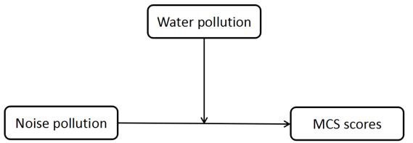
Figure 10. Conceptual diagram

Model = 1 Y = agg_ment X = noise M = water
Statistical Controls:CONTROL= empreln bmi hhdnum religion alcohg smokg
Sample size 3697

**************************************************************************
Outcome: agg_ment

Model Summary
R R-sq MSE F df1 df2 p
.1391 .0194 86.7678 8.1396 9.0000 3687.0000 .0000

Model
coeff se t p LLCI ULCI
constant 42.7542 1.2020 35.5693 .0000 40.3975 45.1108
water -.6561 .3825 -1.7151 .0864 -1.4061 .0939
noise -.1902 .3571 -.5326 .5943 -.8903 .5100
int_1 .2791 .7484 .3730 .7092 -1.1882 1.7465
empreln -.7913 .3374 -2.3456 .0190 -1.4528 -.1299
bmi .2473 .0463 5.3459 .0000 .1566 .3380
hhdnum -.0716 .1411 -.5074 .6119 -.3483 .2051
religion .4574 .4743 .9643 .3350 -.4726 1.3874
alcohg .5409 .3692 1.4653 .1429 -.1829 1.2647
smokg 1.2150 .3534 3.4381 .0006 .5221 1.9078

Interactions:

int_1 noise X water

*************************************************************************

Conditional effect of X on Y at values of the moderator(s):
water Effect se t p LLCI ULCI
-.2659 -.2644 .4348 -.6081 .5432 -1.1169 .5881
.7341 .0147 .6073 .0242 .9807 -1.1759 1.2054

**************************************************************************

Data for visualizing conditional effect of X on Y
Paste text below into a SPSS syntax window and execute to produce plot.

DATA LIST FREE/noise water agg_ment.
BEGIN DATA.

-.3000 -.2659 49.1200
.7000 -.2659 48.8556
-.3000 .7341 48.3802
.7000 .7341 48.3949

END DATA.
GRAPH/SCATTERPLOT=noise WITH agg_ment BY water.

* Estimates are based on setting covariates to their sample means.

******************** ANALYSIS NOTES AND WARNINGS *************************

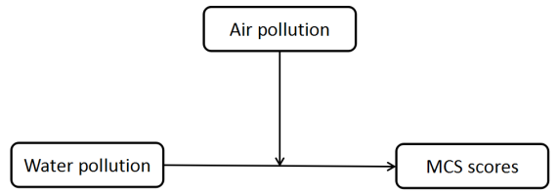
Figure 11. Conceptual diagram

Model = 1 Y = agg_ment X = water M = air
Statistical Controls:CONTROL= empreln bmi hhdnum religion alcohg smokg
Sample size 3697

**************************************************************************
Outcome: agg_ment

Model Summary
R R-sq MSE F df1 df2 p
.1406 .0198 86.7315 8.2739 9.0000 3687.0000 .0000

Model
coeff se t p LLCI ULCI
constant 42.6005 1.2095 35.2203 .0000 40.2291 44.9720
air -.4553 .4011 -1.1350 .2565 -1.2418 .3312
water -.6463 .4449 -1.4527 .1464 -1.5185 .2260
int_1 .8471 .8192 1.0341 .3012 -.7590 2.4532
empreln -.7895 .3377 -2.3378 .0194 -1.4517 -.1274
bmi .2507 .0464 5.4014 .0000 .1597 .3417
hhdnum -.0760 .1411 -.5385 .5903 -.3526 .2007
religion .4838 .4743 1.0200 .3078 -.4461 1.4137
alcohg .5310 .3695 1.4371 .1508 -.1934 1.2554
smokg 1.2159 .3522 3.4522 .0006 .5254 1.9064

Interactions:

int_1 water X air

*************************************************************************

Conditional effect of X on Y at values of the moderator(s):
air Effect se t p LLCI ULCI
-.2905 -.8924 .5808 -1.5365 .1245 -2.0311 .2463
.7095 -.0453 .5775 -.0784 .9375 -1.1776 1.0871

**************************************************************************

Data for visualizing conditional effect of X on Y
Paste text below into a SPSS syntax window and execute to produce plot.

DATA LIST FREE/water air agg_ment.
BEGIN DATA.

-.2659 -.2905 49.1679
.7341 -.2905 48.2755
-.2659 .7095 48.4874
.7341 .7095 48.4421

END DATA.
GRAPH/SCATTERPLOT=water WITH agg_ment BY air.

* Estimates are based on setting covariates to their sample means.

******************** ANALYSIS NOTES AND WARNINGS *************************

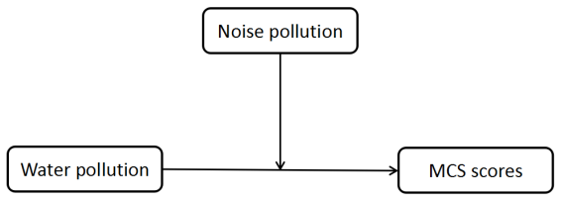
Figure 12. Conceptual diagram

Model = 1 Y = agg_ment X = water M = noise
Statistical Controls:CONTROL= empreln bmi hhdnum religion alcohg smokg
Sample size 3697

**************************************************************************
Outcome: agg_ment

Model Summary
R R-sq MSE F df1 df2 p
.1391 .0194 86.7678 8.1396 9.0000 3687.0000 .0000

Model
coeff se t p LLCI ULCI
constant 42.7542 1.2020 35.5693 .0000 40.3975 45.1108
noise -.1902 .3571 -.5326 .5943 -.8903 .5100
water -.6561 .3825 -1.7151 .0864 -1.4061 .0939
int_1 .2791 .7484 .3730 .7092 -1.1882 1.7465
empreln -.7913 .3374 -2.3456 .0190 -1.4528 -.1299
bmi .2473 .0463 5.3459 .0000 .1566 .3380
hhdnum -.0716 .1411 -.5074 .6119 -.3483 .2051
religion .4574 .4743 .9643 .3350 -.4726 1.3874
alcohg .5409 .3692 1.4653 .1429 -.1829 1.2647
smokg 1.2150 .3534 3.4381 .0006 .5221 1.9078

Interactions:

int_1 water X noise

*************************************************************************

Conditional effect of X on Y at values of the moderator(s):
noise Effect se t p LLCI ULCI
-.3000 -.7399 .4916 -1.5049 .1324 -1.7038 .2241
.7000 -.4607 .5620 -.8197 .4124 -1.5627 .6412

**************************************************************************

Data for visualizing conditional effect of X on Y
Paste text below into a SPSS syntax window and execute to produce plot.

DATA LIST FREE/water noise agg_ment.
BEGIN DATA.

-.2659 -.3000 49.1200
.7341 -.3000 48.3802
-.2659 .7000 48.8556
.7341 .7000 48.3949

END DATA.
GRAPH/SCATTERPLOT=water WITH agg_ment BY noise.

* Estimates are based on setting covariates to their sample means.

******************** ANALYSIS NOTES AND WARNINGS *************************

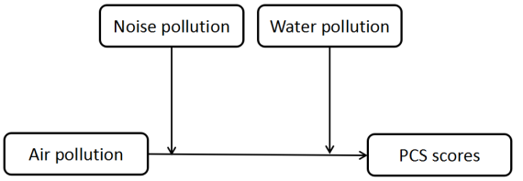
Figure 13. Conceptual diagram

Model = 2
Y = agg_phys X = air M = noise W = water
Statistical Controls:
CONTROL= empreln bmi hhdnum religion alcohg smokg
Sample size 3697

**************************************************************************
Outcome: agg_phys

Model Summary
R R-sq MSE F df1 df2 p
.32 .10 107.89 37.91 11.00 3685.00 .00

Model
coeff se t p LLCI ULCI
constant 43.33 1.32 32.84 .00 40.74 45.92
noise 1.17 .44 2.65 .01 .30 2.03
air .63 .50 1.27 .20 -.34 1.61
int_1 -1.30 .87 -1.49 .14 -3.00 .41
water -1.34 .48 -2.76 .01 -2.29 -.39
int_2 1.96 .91 2.15 .03 .17 3.74
empreln -5.38 .37 -14.70 .00 -6.10 -4.67
bmi .17 .05 3.30 .00 .07 .27
hhdnum .76 .16 4.81 .00 .45 1.08
religion 1.42 .52 2.72 .01 .40 2.44
alcohg -.69 .42 -1.64 .10 -1.51 .13
smokg 3.42 .40 8.50 .00 2.63 4.20

Interactions:

int_1 air X noise
int_2 air X water

R-square increase due to interaction(s):
R2-chng F df1 df2 p
int_1 .00 2.21 1.00 3685.00 .14
int_2 .00 4.61 1.00 3685.00 .03
Both .00 3.04 2.00 3685.00 .05

*************************************************************************

Conditional effect of X on Y at values of the moderator(s):
water noise Effect se t p LLCI ULCI
-.27 -.30 .50 .67 .74 .46 -.82 1.82
-.27 .70 -.80 .80 -1.00 .32 -2.36 .76
.73 -.30 2.46 .86 2.85 .00 .76 4.15
.73 .70 1.16 .84 1.37 .17 -.49 2.82

**************************************************************************

Data for visualizing conditional effect of X on Y
Paste text below into a SPSS syntax window and execute to produce plot.

DATA LIST FREE/air water noise agg_phys.
BEGIN DATA.

-.29 -.27 -.30 49.25
.71 -.27 -.30 49.75
-.29 -.27 .70 50.80
.71 -.27 .70 50.00
-.29 .73 -.30 47.35
.71 .73 -.30 49.80
-.29 .73 .70 48.89
.71 .73 .70 50.05

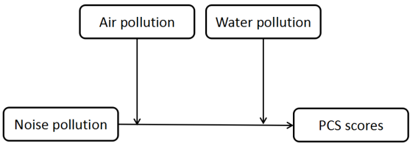
Figure 14. Conceptual diagram

Model = 2 Y = agg_phys X = noise M = air W = water
Statistical Controls:
CONTROL= empreln bmi hhdnum religion alcohg smokg

Sample size 3697

**************************************************************************
Outcome: agg_phys

Model Summary
R R-sq MSE F df1 df2 p
.32 .10 107.99 37.59 11.00 3685.00 .00

Model
coeff se t p LLCI ULCI
constant 43.57 1.31 33.16 .00 40.99 46.14
air .86 .49 1.76 .08 -.10 1.82
noise 1.13 .44 2.55 .01 .26 1.99
int_1 -1.55 .96 -1.62 .11 -3.43 .33
water -1.11 .47 -2.38 .02 -2.03 -.19
int_2 1.12 .92 1.21 .23 -.69 2.93
empreln -5.38 .37 -14.69 .00 -6.10 -4.66
bmi .16 .05 3.24 .00 .06 .26
hhdnum .77 .16 4.81 .00 .45 1.08
religion 1.39 .52 2.65 .01 .36 2.41
alcohg -.68 .42 -1.62 .11 -1.51 .14
smokg 3.42 .40 8.50 .00 2.63 4.21

Interactions:

int_1 noise X air
int_2 noise X water

R-square increase due to interaction(s):
R2-chng F df1 df2 p
int_1 .00 2.61 1.00 3685.00 .11
int_2 .00 1.47 1.00 3685.00 .23
Both .00 1.47 2.00 3685.00 .23

*************************************************************************

Conditional effect of X on Y at values of the moderator(s):
water air Effect se t p LLCI ULCI
-.27 -.29 1.28 .58 2.22 .03 .15 2.41
-.27 .71 -.27 .87 -.31 .76 -1.98 1.44
.73 -.29 2.40 .96 2.51 .01 .53 4.27
.73 .71 .85 .76 1.12 .26 -.63 2.33

**************************************************************************

Data for visualizing conditional effect of X on Y
Paste text below into a SPSS syntax window and execute to produce plot.

DATA LIST FREE/noise water air agg_phys.
BEGIN DATA.

-.30 -.27 -.29 49.20
.70 -.27 -.29 50.48
-.30 -.27 .71 50.53
.70 -.27 .71 50.26
-.30 .73 -.29 47.75
.70 .73 -.29 50.15
-.30 .73 .71 49.08
.70 .73 .71 49.93

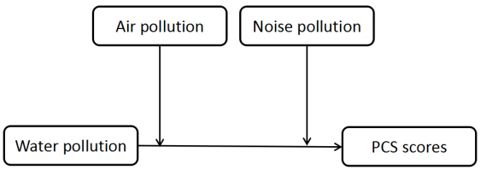
Figure 15. Conceptual diagram

Model = 2 Y = agg_phys X = water M = air W = noise
Statistical Controls:CONTROL= empreln bmi hhdnum religion alcohg smokg
Sample size 3697

**************************************************************************
Outcome: agg_phys

Model Summary
R R-sq MSE F df1 df2 p
.32 .10 107.96 37.69 11.00 3685.00 .00

Model
coeff se t p LLCI ULCI
constant 43.28 1.32 32.81 .00 40.69 45.86
air .47 .49 .97 .33 -.48 1.43
water -1.32 .49 -2.71 .01 -2.27 -.36
int_1 1.86 .98 1.90 .06 -.06 3.79
noise 1.03 .43 2.37 .02 .18 1.88
int_2 -.20 .91 -.22 .82 -1.98 1.57
empreln -5.37 .37 -14.68 .00 -6.09 -4.66
bmi .16 .05 3.25 .00 .07 .26
hhdnum .76 .16 4.80 .00 .45 1.07
religion 1.42 .52 2.71 .01 .39 2.45
alcohg -.69 .42 -1.64 .10 -1.52 .13
smokg 3.43 .40 8.52 .00 2.64 4.22

Interactions:
int_1 water X air
int_2 water X noise
R-square increase due to interaction(s):
R2-chng F df1 df2 p
int_1 .00 3.60 1.00 3685.00 .06
int_2 .00 .05 1.00 3685.00 .82
Both .00 1.96 2.00 3685.00 .14

*************************************************************************

Conditional effect of X on Y at values of the moderator(s):
noise air Effect se t p LLCI ULCI
-.30 -.29 -1.80 .66 -2.74 .01 -3.09 -.51
-.30 .71 .06 .88 .07 .94 -1.67 1.79
.70 -.29 -2.00 .94 -2.13 .03 -3.85 -.16
.70 .71 -.14 .73 -.19 .85 -1.57 1.29

**************************************************************************

Data for visualizing conditional effect of X on Y
Paste text below into a SPSS syntax window and execute to produce plot.

DATA LIST FREE/water noise air agg_phys.
BEGIN DATA.
-.27 -.30 -.29 49.32
.73 -.30 -.29 47.52
-.27 -.30 .71 49.30
.73 -.30 .71 49.36
-.27 .70 -.29 50.40
.73 .70 -.29 48.40
-.27 .70 .71 50.38
.73 .70 .71 50.24

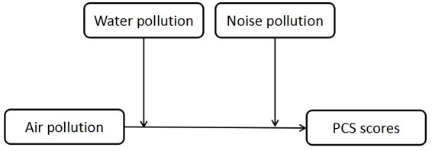
Figure 16. Conceptual diagram

Model = 2 Y = agg_phys X = air M = water W = noise
Statistical Controls:CONTROL= empreln bmi hhdnum religion alcohg smokg
Sample size 3697

**************************************************************************
Outcome: agg_phys

Model Summary
R R-sq MSE F df1 df2 p
.32 .10 107.89 37.91 11.00 3685.00 .00

Model
coeff se t p LLCI ULCI
constant 43.33 1.32 32.84 .00 40.74 45.92
water -1.34 .48 -2.76 .01 -2.29 -.39
air .63 .50 1.27 .20 -.34 1.61
int_1 1.96 .91 2.15 .03 .17 3.74
noise 1.17 .44 2.65 .01 .30 2.03
int_2 -1.30 .87 -1.49 .14 -3.00 .41
empreln -5.38 .37 -14.70 .00 -6.10 -4.67
bmi .17 .05 3.30 .00 .07 .27
hhdnum .76 .16 4.81 .00 .45 1.08
religion 1.42 .52 2.72 .01 .40 2.44
alcohg -.69 .42 -1.64 .10 -1.51 .13
smokg 3.42 .40 8.50 .00 2.63 4.20

Interactions:

int_1 air X water
int_2 air X noise

R-square increase due to interaction(s):
R2-chng F df1 df2 p
int_1 .00 4.61 1.00 3685.00 .03
int_2 .00 2.21 1.00 3685.00 .14
Both .00 3.04 2.00 3685.00 .05

*************************************************************************

Conditional effect of X on Y at values of the moderator(s):
noise water Effect se t p LLCI ULCI
-.30 -.27 .50 .67 .74 .46 -.82 1.82
-.30 .73 2.46 .86 2.85 .00 .76 4.15
.70 -.27 -.80 .80 -1.00 .32 -2.36 .76
.70 .73 1.16 .84 1.37 .17 -.49 2.82

**************************************************************************

Data for visualizing conditional effect of X on Y
Paste text below into a SPSS syntax window and execute to produce plot.

DATA LIST FREE/air noise water agg_phys.
BEGIN DATA.

-.29 -.30 -.27 49.25
.71 -.30 -.27 49.75
-.29 -.30 .73 47.35
.71 -.30 .73 49.80
-.29 .70 -.27 50.80
.71 .70 -.27 50.00
-.29 .70 .73 48.89
.71 .70 .73 50.05

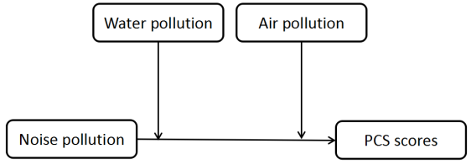
Figure 17. Conceptual diagram

Model = 2 Y = agg_phys X = noise M = water W = air

Statistical Controls:CONTROL= empreln bmi hhdnum religion alcohg smokg
Sample size 3697

**************************************************************************
Outcome: agg_phys

Model Summary
R R-sq MSE F df1 df2 p
.32 .10 107.99 37.59 11.00 3685.00 .00

Model
coeff se t p LLCI ULCI
constant 43.57 1.31 33.16 .00 40.99 46.14
water -1.11 .47 -2.38 .02 -2.03 -.19
noise 1.13 .44 2.55 .01 .26 1.99
int_1 1.12 .92 1.21 .23 -.69 2.93
air .86 .49 1.76 .08 -.10 1.82
int_2 -1.55 .96 -1.62 .11 -3.43 .33
empreln -5.38 .37 -14.69 .00 -6.10 -4.66
bmi .16 .05 3.24 .00 .06 .26
hhdnum .77 .16 4.81 .00 .45 1.08
religion 1.39 .52 2.65 .01 .36 2.41
alcohg -.68 .42 -1.62 .11 -1.51 .14
smokg 3.42 .40 8.50 .00 2.63 4.21

Interactions:

int_1 noise X water
int_2 noise X air

R-square increase due to interaction(s):
R2-chng F df1 df2 p
int_1 .00 1.47 1.00 3685.00 .23
int_2 .00 2.61 1.00 3685.00 .11
Both .00 1.47 2.00 3685.00 .23

*************************************************************************

Conditional effect of X on Y at values of the moderator(s):
air water Effect se t p LLCI ULCI
-.29 -.27 1.28 .58 2.22 .03 .15 2.41
-.29 .73 2.40 .96 2.51 .01 .53 4.27
.71 -.27 -.27 .87 -.31 .76 -1.98 1.44
.71 .73 .85 .76 1.12 .26 -.63 2.33

**************************************************************************

Data for visualizing conditional effect of X on Y
Paste text below into a SPSS syntax window and execute to produce plot.

DATA LIST FREE/noise air water agg_phys.
BEGIN DATA.

-.30 -.29 -.27 49.20
.70 -.29 -.27 50.48
-.30 -.29 .73 47.75
.70 -.29 .73 50.15
-.30 .71 -.27 50.53
.70 .71 -.27 50.26
-.30 .71 .73 49.08
.70 .71 .73 49.93

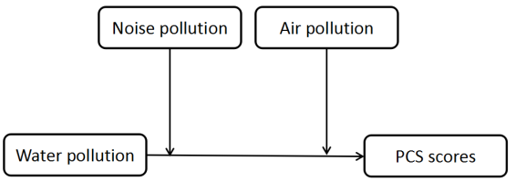
Figure 18. Conceptual diagram

Model = 2 Y = agg_phys X = water M = noise W = air

Statistical Controls:
CONTROL= empreln bmi hhdnum religion alcohg smokg
Sample size 3697

**************************************************************************
Outcome: agg_phys

Model Summary
R R-sq MSE F df1 df2 p
.32 .10 107.96 37.69 11.00 3685.00 .00

Model
coeff se t p LLCI ULCI
constant 43.28 1.32 32.81 .00 40.69 45.86
noise 1.03 .43 2.37 .02 .18 1.88
water -1.32 .49 -2.71 .01 -2.27 -.36
int_1 -.20 .91 -.22 .82 -1.98 1.57
air .47 .49 .97 .33 -.48 1.43
int_2 1.86 .98 1.90 .06 -.06 3.79
empreln -5.37 .37 -14.68 .00 -6.09 -4.66
bmi .16 .05 3.25 .00 .07 .26
hhdnum .76 .16 4.80 .00 .45 1.07
religion 1.42 .52 2.71 .01 .39 2.45
alcohg -.69 .42 -1.64 .10 -1.52 .13
smokg 3.43 .40 8.52 .00 2.64 4.22

Interactions:
int_1 water X noise
int_2 water X air
R-square increase due to interaction(s):
R2-chng F df1 df2 p
int_1 .00 .05 1.00 3685.00 .82
int_2 .00 3.60 1.00 3685.00 .06
Both .00 1.96 2.00 3685.00 .14

*************************************************************************

Conditional effect of X on Y at values of the moderator(s):
air noise Effect se t p LLCI ULCI
-.29 -.30 -1.80 .66 -2.74 .01 -3.09 -.51
-.29 .70 -2.00 .94 -2.13 .03 -3.85 -.16
.71 -.30 .06 .88 .07 .94 -1.67 1.79
.71 .70 -.14 .73 -.19 .85 -1.57 1.29

**************************************************************************

Data for visualizing conditional effect of X on Y
Paste text below into a SPSS syntax window and execute to produce plot.

DATA LIST FREE/water air noise agg_phys.
BEGIN DATA.

-.27 -.29 -.30 49.32
.73 -.29 -.30 47.52
-.27 -.29 .70 50.40
.73 -.29 .70 48.40
-.27 .71 -.30 49.30
.73 .71 -.30 49.36
-.27 .71 .70 50.38
.73 .71 .70 50.24

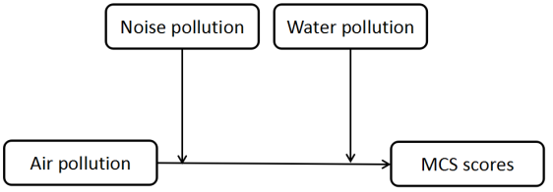
Figure 19. Conceptual diagram
Model = 2 Y = agg_ment X = air M = noise W = water
Statistical Controls:CONTROL= empreln bmi hhdnum religion alcohg smokg

Sample size
3697

**************************************************************************
Outcome: agg_ment

Model Summary
R R-sq MSE F df1 df2 p
.14 .02 86.73 6.93 11.00 3685.00 .00

Model
coeff se t p LLCI ULCI
constant 42.55 1.18 35.97 .00 40.23 44.87
noise -.19 .40 -.48 .63 -.97 .59
air -.56 .45 -1.25 .21 -1.43 .32
int_1 1.07 .78 1.37 .17 -.46 2.60
water -.63 .43 -1.45 .15 -1.48 .22
int_2 .70 .82 .86 .39 -.90 2.30
empreln -.78 .33 -2.38 .02 -1.42 -.14
bmi .25 .05 5.47 .00 .16 .34
hhdnum -.08 .14 -.54 .59 -.36 .20
religion .48 .47 1.02 .31 -.44 1.40
alcohg .53 .38 1.40 .16 -.21 1.27
smokg 1.23 .36 3.42 .00 .53 1.94

Interactions:

int_1 air X noise
int_2 air X water

R-square increase due to interaction(s):
R2-chng F df1 df2 p
int_1 .00 1.87 1.00 3685.00 .17
int_2 .00 .73 1.00 3685.00 .39
Both .00 1.49 2.00 3685.00 .23

*************************************************************************

Conditional effect of X on Y at values of the moderator(s):
water noise Effect se t p LLCI ULCI
-.27 -.30 -1.06 .60 -1.76 .08 -2.25 .12
-.27 .70 .01 .71 .01 .99 -1.39 1.41
.73 -.30 -.36 .77 -.47 .64 -1.88 1.15
.73 .70 .71 .76 .93 .35 -.78 2.19

**************************************************************************

Data for visualizing conditional effect of X on Y
Paste text below into a SPSS syntax window and execute to produce plot.

DATA LIST FREE/air water noise agg_ment.
BEGIN DATA.

-.29 -.27 -.30 49.24
.71 -.27 -.30 48.18
-.29 -.27 .70 48.74
.71 -.27 .70 48.75
-.29 .73 -.30 48.41
.71 .73 -.30 48.04
-.29 .73 .70 47.91
.71 .73 .70 48.61

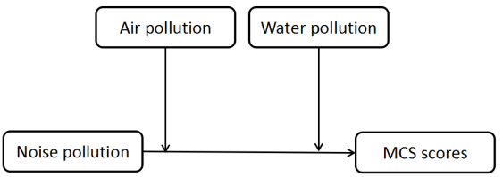
Figure 20. Conceptual diagram

Model = 2 Y = agg_ment X = noise M = air W = water
Statistical Controls:CONTROL= empreln bmi hhdnum religion alcohg smokg
Sample size 3697

**************************************************************************
Outcome: agg_ment

Model Summary
R R-sq MSE F df1 df2 p
.14 .02 86.75 6.87 11.00 3685.00 .00

Model
coeff se t p LLCI ULCI
constant 42.66 1.18 36.22 .00 40.35 44.97
air -.50 .44 -1.13 .26 -1.36 .36
noise -.19 .40 -.47 .64 -.97 .59
int_1 1.26 .86 1.47 .14 -.43 2.95
water -.48 .42 -1.14 .26 -1.30 .35
int_2 -.22 .83 -.27 .79 -1.85 1.40
empreln -.78 .33 -2.37 .02 -1.42 -.13
bmi .25 .05 5.43 .00 .16 .34
hhdnum -.08 .14 -.54 .59 -.36 .20
religion .48 .47 1.03 .30 -.44 1.40
alcohg .53 .38 1.41 .16 -.21 1.27
smokg 1.23 .36 3.40 .00 .52 1.93

Interactions:

int_1 noise X air
int_2 noise X water

R-square increase due to interaction(s):
R2-chng F df1 df2 p
int_1 .00 2.15 1.00 3685.00 .14
int_2 .00 .07 1.00 3685.00 .79
Both .00 1.16 2.00 3685.00 .31

*************************************************************************

Conditional effect of X on Y at values of the moderator(s):
water air Effect se t p LLCI ULCI
-.27 -.29 -.49 .52 -.96 .34 -1.51 .52
-.27 .71 .76 .78 .98 .33 -.77 2.30
.73 -.29 -.72 .86 -.84 .40 -2.40 .96
.73 .71 .54 .68 .80 .42 -.79 1.87

**************************************************************************

Data for visualizing conditional effect of X on Y
Paste text below into a SPSS syntax window and execute to produce plot.

DATA LIST FREE/noise water air agg_ment.
BEGIN DATA.

-.30 -.27 -.29 49.20
.70 -.27 -.29 48.70
-.30 -.27 .71 48.32
.70 -.27 .71 49.09
-.30 .73 -.29 48.79
.70 .73 -.29 48.07
-.30 .73 .71 47.91
.70 .73 .71 48.45

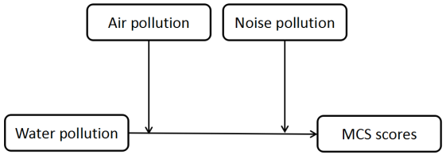
Figure 21. Conceptual diagram

Model = 2 Y = agg_ment X = water M = air W = noise
Statistical Controls:CONTROL= empreln bmi hhdnum religion alcohg smokg
Sample size 3697

**************************************************************************
Outcome: agg_ment

Model Summary
R R-sq MSE F df1 df2 p
.14 .02 86.78 6.76 11.00 3685.00 .00

Model
coeff se t p LLCI ULCI
constant 42.60 1.18 36.02 .00 40.28 44.92
air -.43 .44 -.99 .32 -1.29 .43
water -.64 .44 -1.46 .14 -1.49 .22
int_1 .85 .88 .97 .33 -.87 2.58
noise -.06 .39 -.16 .87 -.83 .70
int_2 .00 .81 -.01 1.00 -1.60 1.59
empreln -.79 .33 -2.40 .02 -1.43 -.14
bmi .25 .05 5.52 .00 .16 .34
hhdnum -.08 .14 -.54 .59 -.36 .20
religion .48 .47 1.03 .30 -.44 1.40
alcohg .53 .38 1.41 .16 -.21 1.27
smokg 1.22 .36 3.38 .00 .51 1.93

Interactions:

int_1 water X air
int_2 water X noise

R-square increase due to interaction(s):
R2-chng F df1 df2 p
int_1 .00 .94 1.00 3685.00 .33
int_2 .00 .00 1.00 3685.00 1.00
Both .00 .55 2.00 3685.00 .58

*************************************************************************

Conditional effect of X on Y at values of the moderator(s):
noise air Effect se t p LLCI ULCI
-.30 -.29 -.88 .59 -1.50 .13 -2.04 .27
-.30 .71 -.03 .79 -.04 .97 -1.58 1.52
.70 -.29 -.89 .84 -1.05 .29 -2.54 .77
.70 .71 -.04 .66 -.06 .96 -1.32 1.25

**************************************************************************

Data for visualizing conditional effect of X on Y
Paste text below into a SPSS syntax window and execute to produce plot.

DATA LIST FREE/water noise air agg_ment.
BEGIN DATA.

-.27 -.30 -.29 49.18
.73 -.30 -.29 48.29
-.27 -.30 .71 48.52
.73 -.30 .71 48.49
-.27 .70 -.29 49.12
.73 .70 -.29 48.23
-.27 .70 .71 48.46
.73 .70 .71 48.42

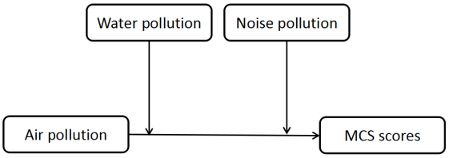
Figure 22. Conceptual diagram

Model = 2 Y = agg_ment X = air M = water W = noise
Statistical Controls:CONTROL= empreln bmi hhdnum religion alcohg smokg

Sample size 3697

**************************************************************************
Outcome: agg_ment

Model Summary
R R-sq MSE F df1 df2 p
.14 .02 86.73 6.93 11.00 3685.00 .00

Model
coeff se t p LLCI ULCI
constant 42.55 1.18 35.97 .00 40.23 44.87
water -.63 .43 -1.45 .15 -1.48 .22
air -.56 .45 -1.25 .21 -1.43 .32
int_1 .70 .82 .86 .39 -.90 2.30
noise -.19 .40 -.48 .63 -.97 .59
int_2 1.07 .78 1.37 .17 -.46 2.60
empreln -.78 .33 -2.38 .02 -1.42 -.14
bmi .25 .05 5.47 .00 .16 .34
hhdnum -.08 .14 -.54 .59 -.36 .20
religion .48 .47 1.02 .31 -.44 1.40
alcohg .53 .38 1.40 .16 -.21 1.27
smokg 1.23 .36 3.42 .00 .53 1.94

Interactions:
int_1 air X water
int_2 air X noise

R-square increase due to interaction(s):
R2-chng F df1 df2 p
int_1 .00 .73 1.00 3685.00 .39
int_2 .00 1.87 1.00 3685.00 .17
Both .00 1.49 2.00 3685.00 .23

*************************************************************************

Conditional effect of X on Y at values of the moderator(s):
noise water Effect se t p LLCI ULCI
-.30 -.27 -1.06 .60 -1.76 .08 -2.25 .12
-.30 .73 -.36 .77 -.47 .64 -1.88 1.15
.70 -.27 .01 .71 .01 .99 -1.39 1.41
.70 .73 .71 .76 .93 .35 -.78 2.19

**************************************************************************

Data for visualizing conditional effect of X on Y
Paste text below into a SPSS syntax window and execute to produce plot.

DATA LIST FREE/air noise water agg_ment.
BEGIN DATA.

-.29 -.30 -.27 49.24
.71 -.30 -.27 48.18
-.29 -.30 .73 48.41
.71 -.30 .73 48.04
-.29 .70 -.27 48.74
.71 .70 -.27 48.75
-.29 .70 .73 47.91
.71 .70 .73 48.61

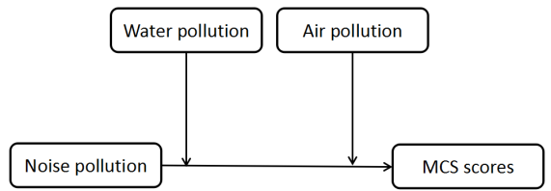
Figure 23. Conceptual diagram

Model = 2 Y = agg_ment X = noise M = water W = air
Statistical Controls:CONTROL= empreln bmi hhdnum religion alcohg smokg
Sample size 3697

**************************************************************************
Outcome: agg_ment

Model Summary
R R-sq MSE F df1 df2 p
.14 .02 86.75 6.87 11.00 3685.00 .00

Model
coeff se t p LLCI ULCI
constant 42.66 1.18 36.22 .00 40.35 44.97
water -.48 .42 -1.14 .26 -1.30 .35
noise -.19 .40 -.47 .64 -.97 .59
int_1 -.22 .83 -.27 .79 -1.85 1.40
air -.50 .44 -1.13 .26 -1.36 .36
int_2 1.26 .86 1.47 .14 -.43 2.95
empreln -.78 .33 -2.37 .02 -1.42 -.13
bmi .25 .05 5.43 .00 .16 .34
hhdnum -.08 .14 -.54 .59 -.36 .20
religion .48 .47 1.03 .30 -.44 1.40
alcohg .53 .38 1.41 .16 -.21 1.27
smokg 1.23 .36 3.40 .00 .52 1.93

Interactions:

int_1 noise X water
int_2 noise X air

R-square increase due to interaction(s):
R2-chng F df1 df2 p
int_1 .00 .07 1.00 3685.00 .79
int_2 .00 2.15 1.00 3685.00 .14
Both .00 1.16 2.00 3685.00 .31

*************************************************************************

Conditional effect of X on Y at values of the moderator(s):
air water Effect se t p LLCI ULCI
-.29 -.27 -.49 .52 -.96 .34 -1.51 .52
-.29 .73 -.72 .86 -.84 .40 -2.40 .96
.71 -.27 .76 .78 .98 .33 -.77 2.30
.71 .73 .54 .68 .80 .42 -.79 1.87

**************************************************************************

Data for visualizing conditional effect of X on Y
Paste text below into a SPSS syntax window and execute to produce plot.

DATA LIST FREE/noise air water agg_ment.
BEGIN DATA.

-.30 -.29 -.27 49.20
.70 -.29 -.27 48.70
-.30 -.29 .73 48.79
.70 -.29 .73 48.07
-.30 .71 -.27 48.32
.70 .71 -.27 49.09
-.30 .71 .73 47.91
.70 .71 .73 48.45

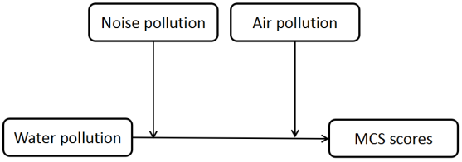
Figure 24. Conceptual diagram

Model = 2 Y = agg_ment X = water M = noise W = air
Statistical Controls:CONTROL= empreln bmi hhdnum religion alcohg smokg
Sample size 3697

**************************************************************************
Outcome: agg_ment

Model Summary
R R-sq MSE F df1 df2 p
.14 .02 86.78 6.76 11.00 3685.00 .00

Model
coeff se t p LLCI ULCI
constant 42.60 1.18 36.02 .00 40.28 44.92
noise -.06 .39 -.16 .87 -.83 .70
water -.64 .44 -1.46 .14 -1.49 .22
int_1 .00 .81 -.01 1.00 -1.60 1.59
air -.43 .44 -.99 .32 -1.29 .43
int_2 .85 .88 .97 .33 -.87 2.58
empreln -.79 .33 -2.40 .02 -1.43 -.14
bmi .25 .05 5.52 .00 .16 .34
hhdnum -.08 .14 -.54 .59 -.36 .20
religion .48 .47 1.03 .30 -.44 1.40
alcohg .53 .38 1.41 .16 -.21 1.27
smokg 1.22 .36 3.38 .00 .51 1.93

Interactions:
int_1 water X noise
int_2 water X air

R-square increase due to interaction(s):
R2-chng F df1 df2 p
int_1 .00 .00 1.00 3685.00 1.00
int_2 .00 .94 1.00 3685.00 .33
Both .00 .55 2.00 3685.00 .58

*************************************************************************

Conditional effect of X on Y at values of the moderator(s):
air noise Effect se t p LLCI ULCI
-.29 -.30 -.88 .59 -1.50 .13 -2.04 .27
-.29 .70 -.89 .84 -1.05 .29 -2.54 .77
.71 -.30 -.03 .79 -.04 .97 -1.58 1.52
.71 .70 -.04 .66 -.06 .96 -1.32 1.25

**************************************************************************

Data for visualizing conditional effect of X on Y
Paste text below into a SPSS syntax window and execute to produce plot.

DATA LIST FREE/water air noise agg_ment.
BEGIN DATA.

-.27 -.29 -.30 49.18
.73 -.29 -.30 48.29
-.27 -.29 .70 49.12
.73 -.29 .70 48.23
-.27 .71 -.30 48.52
.73 .71 -.30 48.49
-.27 .71 .70 48.46
.73 .71 .70 48.42

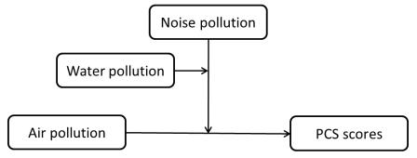
Figure 25. Conceptual diagram

Model = 3 Y = agg_phys X = air M = noise W = water

Statistical Controls:CONTROL= empreln bmi hhdnum religion alcohg smokg
Sample size 3697

**************************************************************************
Outcome: agg_phys

Model Summary
R R-sq MSE F df1 df2 p
.32 .10 107.94 29.84 13.00 3683.00 .00

Model
coeff se t p LLCI ULCI
constant 43.35 1.41 30.83 .00 40.59 46.11
noise 1.09 .47 2.31 .02 .16 2.01
air .68 .50 1.36 .17 -.30 1.66
int_1 -1.56 .96 -1.63 .10 -3.44 .32
water -1.42 .54 -2.64 .01 -2.47 -.36
int_2 1.69 1.02 1.66 .10 -.31 3.69
int_3 .21 1.17 .18 .86 -2.09 2.51
int_4 .92 2.03 .45 .65 -3.05 4.90
empreln -5.38 .39 -13.66 .00 -6.16 -4.61
bmi .17 .05 3.07 .00 .06 .27
hhdnum .77 .17 4.60 .00 .44 1.09
religion 1.41 .54 2.62 .01 .36 2.47
alcohg -.69 .41 -1.68 .09 -1.49 .11
smokg 3.42 .39 8.81 .00 2.66 4.18

Interactions:

int_1 air X noise
int_2 air X water
int_3 noise X water
int_4 air X noise X water

*************************************************************************

Conditional effect of X on Y at values of the moderator(s):
water noise Effect se t p LLCI ULCI
-.27 -.30 .77 .80 .97 .33 -.79 2.34
-.27 .70 -1.03 .84 -1.22 .22 -2.68 .62
.73 -.30 2.19 1.03 2.13 .03 .18 4.21
.73 .70 1.31 1.31 1.00 .32 -1.26 3.87

Conditional effect of X*M interaction at values of W:
water Effect se t p LLCI ULCI
-.27 -1.81 1.16 -1.56 .12 -4.08 .47
.73 -.89 1.66 -.53 .59 -4.15 2.38

**************************************************************************

Data for visualizing conditional effect of X on Y
Paste text below into a SPSS syntax window and execute to produce plot.

DATA LIST FREE/air water noise agg_phys.
BEGIN DATA.

-.29 -.27 -.30 49.25
.71 -.27 -.30 50.03
-.29 -.27 .70 50.81
.71 -.27 .70 49.77
-.29 .73 -.30 47.36
.71 .73 -.30 49.55
-.29 .73 .70 48.86
.71 .73 .70 50.16

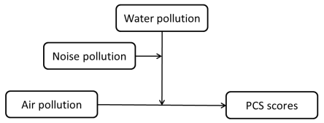
Figure 26. Conceptual diagram

Model = 3 Y = agg_phys X = air M = water W = noise
Statistical Controls:CONTROL= empreln bmi hhdnum religion alcohg smokg
Sample size 3697

**************************************************************************
Outcome: agg_phys

Model Summary
R R-sq MSE F df1 df2 p
.32 .10 107.94 29.84 13.00 3683.00 .00

Model
coeff se t p LLCI ULCI
constant 43.35 1.41 30.83 .00 40.59 46.11
water -1.42 .54 -2.64 .01 -2.47 -.36
air .68 .50 1.36 .17 -.30 1.66
int_1 1.69 1.02 1.66 .10 -.31 3.69
noise 1.09 .47 2.31 .02 .16 2.01
int_2 -1.56 .96 -1.63 .10 -3.44 .32
int_3 .21 1.17 .18 .86 -2.09 2.51
int_4 .92 2.03 .45 .65 -3.05 4.90
empreln -5.38 .39 -13.66 .00 -6.16 -4.61
bmi .17 .05 3.07 .00 .06 .27
hhdnum .77 .17 4.60 .00 .44 1.09
religion 1.41 .54 2.62 .01 .36 2.47
alcohg -.69 .41 -1.68 .09 -1.49 .11
smokg 3.42 .39 8.81 .00 2.66 4.18

Interactions:

int_1 air X water
int_2 air X noise
int_3 water X noise
int_4 air X water X noise

*************************************************************************

Conditional effect of X on Y at values of the moderator(s):
noise water Effect se t p LLCI ULCI
-.30 -.27 .77 .80 .97 .33 -.79 2.34
-.30 .73 2.19 1.03 2.13 .03 .18 4.21
.70 -.27 -1.03 .84 -1.22 .22 -2.68 .62
.70 .73 1.31 1.31 1.00 .32 -1.26 3.87

Conditional effect of X*M interaction at values of W:
noise Effect se t p LLCI ULCI
-.30 1.42 1.30 1.09 .28 -1.13 3.96
.70 2.34 1.55 1.50 .13 -.71 5.38

**************************************************************************

Data for visualizing conditional effect of X on Y
Paste text below into a SPSS syntax window and execute to produce plot.

DATA LIST FREE/air noise water agg_phys.
BEGIN DATA.

-.29 -.30 -.27 49.25
.71 -.30 -.27 50.03
-.29 -.30 .73 47.36
.71 -.30 .73 49.55
-.29 .70 -.27 50.81
.71 .70 -.27 49.77
-.29 .70 .73 48.86
.71 .70 .73 50.16

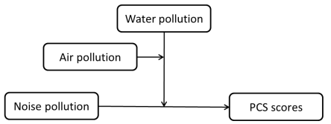
Figure 27. Conceptual diagram

Model = 3 Y = agg_phys X = noise M = water W = air
Statistical Controls:CONTROL= empreln bmi hhdnum religion alcohg smokg
Sample size 3697

**************************************************************************
Outcome: agg_phys

Model Summary
R R-sq MSE F df1 df2 p
.32 .10 107.94 29.84 13.00 3683.00 .00

Model
coeff se t p LLCI ULCI
constant 43.35 1.41 30.83 .00 40.59 46.11
water -1.42 .54 -2.64 .01 -2.47 -.36
noise 1.09 .47 2.31 .02 .16 2.01
int_1 .21 1.17 .18 .86 -2.09 2.51
air .68 .50 1.36 .17 -.30 1.66
int_2 -1.56 .96 -1.63 .10 -3.44 .32
int_3 1.69 1.02 1.66 .10 -.31 3.69
int_4 .92 2.03 .45 .65 -3.05 4.90
empreln -5.38 .39 -13.66 .00 -6.16 -4.61
bmi .17 .05 3.07 .00 .06 .27
hhdnum .77 .17 4.60 .00 .44 1.09
religion 1.41 .54 2.62 .01 .36 2.47
alcohg -.69 .41 -1.68 .09 -1.49 .11
smokg 3.42 .39 8.81 .00 2.66 4.18

Interactions:

int_1 noise X water
int_2 noise X air
int_3 water X air
int_4 noise X water X air

*************************************************************************

Conditional effect of X on Y at values of the moderator(s):
air water Effect se t p LLCI ULCI
-.29 -.27 1.55 .60 2.59 .01 .38 2.73
-.29 .73 1.50 1.44 1.04 .30 -1.33 4.33
.71 -.27 -.25 .99 -.25 .80 -2.20 1.70
.71 .73 .61 .83 .74 .46 -1.01 2.23

Conditional effect of X*M interaction at values of W:
air Effect se t p LLCI ULCI
-.29 -.06 1.56 -.04 .97 -3.12 3.01
.71 .86 1.29 .67 .50 -1.67 3.40

**************************************************************************

Data for visualizing conditional effect of X on Y
Paste text below into a SPSS syntax window and execute to produce plot.

DATA LIST FREE/noise air water agg_phys.
BEGIN DATA.

-.30 -.29 -.27 49.25
.70 -.29 -.27 50.81
-.30 -.29 .73 47.36
.70 -.29 .73 48.86
-.30 .71 -.27 50.03
.70 .71 -.27 49.77
-.30 .71 .73 49.55
.70 .71 .73 50.16

END DATA.
GRAPH/SCATTERPLOT=noise WITH agg_phys BY water/PANEL ROWVAR=air.

* Estimates are based on setting covariates to their sample means.

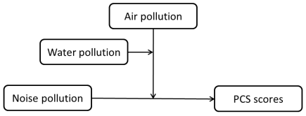
Figure 28. Conceptual diagram

Model = 3 Y = agg_phys X = noise M = air W = water

Statistical Controls:
CONTROL= empreln bmi hhdnum religion alcohg smokg
Sample size 3697

**************************************************************************
Outcome: agg_phys

Model Summary
R R-sq MSE F df1 df2 p
.32 .10 107.94 29.84 13.00 3683.00 .00

Model
coeff se t p LLCI ULCI
constant 43.35 1.41 30.83 .00 40.59 46.11
air .68 .50 1.36 .17 -.30 1.66
noise 1.09 .47 2.31 .02 .16 2.01
int_1 -1.56 .96 -1.63 .10 -3.44 .32
water -1.42 .54 -2.64 .01 -2.47 -.36
int_2 .21 1.17 .18 .86 -2.09 2.51
int_3 1.69 1.02 1.66 .10 -.31 3.69
int_4 .92 2.03 .45 .65 -3.05 4.90
empreln -5.38 .39 -13.66 .00 -6.16 -4.61
bmi .17 .05 3.07 .00 .06 .27
hhdnum .77 .17 4.60 .00 .44 1.09
religion 1.41 .54 2.62 .01 .36 2.47
alcohg -.69 .41 -1.68 .09 -1.49 .11
smokg 3.42 .39 8.81 .00 2.66 4.18

Interactions:

int_1 noise X air
int_2 noise X water
int_3 air X water
int_4 noise X air X water

*************************************************************************

Conditional effect of X on Y at values of the moderator(s):
water air Effect se t p LLCI ULCI
-.27 -.29 1.55 .60 2.59 .01 .38 2.73
-.27 .71 -.25 .99 -.25 .80 -2.20 1.70
.73 -.29 1.50 1.44 1.04 .30 -1.33 4.33
.73 .71 .61 .83 .74 .46 -1.01 2.23

Conditional effect of X*M interaction at values of W:
water Effect se t p LLCI ULCI
-.27 -1.81 1.16 -1.56 .12 -4.08 .47
.73 -.89 1.66 -.53 .59 -4.15 2.38

**************************************************************************

Data for visualizing conditional effect of X on Y
Paste text below into a SPSS syntax window and execute to produce plot.

DATA LIST FREE/noise water air agg_phys.
BEGIN DATA.

-.30 -.27 -.29 49.25
.70 -.27 -.29 50.81
-.30 -.27 .71 50.03
.70 -.27 .71 49.77
-.30 .73 -.29 47.36
.70 .73 -.29 48.86
-.30 .73 .71 49.55
.70 .73 .71 50.16

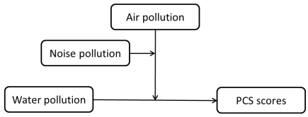
Figure 29. Conceptual diagram
Model = 3 Y = agg_phys X = water M = air W = noise
Statistical Controls:CONTROL= empreln bmi hhdnum religion alcohg smokg
Sample size 3697

**************************************************************************
Outcome: agg_phys

Model Summary
R R-sq MSE F df1 df2 p
.32 .10 107.94 29.84 13.00 3683.00 .00

Model
coeff se t p LLCI ULCI
constant 43.35 1.41 30.83 .00 40.59 46.11
air .68 .50 1.36 .17 -.30 1.66
water -1.42 .54 -2.64 .01 -2.47 -.36
int_1 1.69 1.02 1.66 .10 -.31 3.69
noise 1.09 .47 2.31 .02 .16 2.01
int_2 .21 1.17 .18 .86 -2.09 2.51
int_3 -1.56 .96 -1.63 .10 -3.44 .32
int_4 .92 2.03 .45 .65 -3.05 4.90
empreln -5.38 .39 -13.66 .00 -6.16 -4.61
bmi .17 .05 3.07 .00 .06 .27
hhdnum .77 .17 4.60 .00 .44 1.09
religion 1.41 .54 2.62 .01 .36 2.47
alcohg -.69 .41 -1.68 .09 -1.49 .11
smokg 3.42 .39 8.81 .00 2.66 4.18

Interactions:

int_1 water X air
int_2 water X noise
int_3 air X noise
int_4 water X air X noise

*************************************************************************

Conditional effect of X on Y at values of the moderator(s):
noise air Effect se t p LLCI ULCI
-.30 -.29 -1.89 .80 -2.36 .02 -3.46 -.32
-.30 .71 -.48 1.02 -.47 .64 -2.48 1.53
.70 -.29 -1.95 1.34 -1.45 .15 -4.58 .68
.70 .71 .39 .79 .49 .62 -1.16 1.93

Conditional effect of X*M interaction at values of W:
noise Effect se t p LLCI ULCI
-.30 1.42 1.30 1.09 .28 -1.13 3.96
.70 2.34 1.55 1.50 .13 -.71 5.38

**************************************************************************

Data for visualizing conditional effect of X on Y
Paste text below into a SPSS syntax window and execute to produce plot.

DATA LIST FREE/water noise air agg_phys.
BEGIN DATA.

-.27 -.30 -.29 49.25
.73 -.30 -.29 47.36
-.27 -.30 .71 50.03
.73 -.30 .71 49.55
-.27 .70 -.29 50.81
.73 .70 -.29 48.86
-.27 .70 .71 49.77
.73 .70 .71 50.16

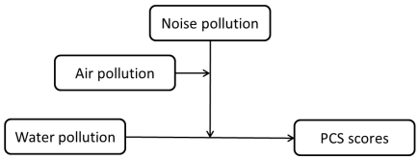
Figure 30. Conceptual diagram

Model = 3 Y = agg_phys X = water M = noise W = air
Statistical Controls:CONTROL= empreln bmi hhdnum religion alcohg smokg
Sample size 3697

**************************************************************************
Outcome: agg_phys

Model Summary
R R-sq MSE F df1 df2 p
.32 .10 107.94 29.84 13.00 3683.00 .00

Model
coeff se t p LLCI ULCI
constant 43.35 1.41 30.83 .00 40.59 46.11
noise 1.09 .47 2.31 .02 .16 2.01
water -1.42 .54 -2.64 .01 -2.47 -.36
int_1 .21 1.17 .18 .86 -2.09 2.51
air .68 .50 1.36 .17 -.30 1.66
int_2 1.69 1.02 1.66 .10 -.31 3.69
int_3 -1.56 .96 -1.63 .10 -3.44 .32
int_4 .92 2.03 .45 .65 -3.05 4.90
empreln -5.38 .39 -13.66 .00 -6.16 -4.61
bmi .17 .05 3.07 .00 .06 .27
hhdnum .77 .17 4.60 .00 .44 1.09
religion 1.41 .54 2.62 .01 .36 2.47
alcohg -.69 .41 -1.68 .09 -1.49 .11
smokg 3.42 .39 8.81 .00 2.66 4.18

Interactions:

int_1 water X noise
int_2 water X air
int_3 noise X air
int_4 water X noise X air

*************************************************************************

Conditional effect of X on Y at values of the moderator(s):
air noise Effect se t p LLCI ULCI
-.29 -.30 -1.89 .80 -2.36 .02 -3.46 -.32
-.29 .70 -1.95 1.34 -1.45 .15 -4.58 .68
.71 -.30 -.48 1.02 -.47 .64 -2.48 1.53
.71 .70 .39 .79 .49 .62 -1.16 1.93

Conditional effect of X*M interaction at values of W:
air Effect se t p LLCI ULCI
-.29 -.06 1.56 -.04 .97 -3.12 3.01
.71 .86 1.29 .67 .50 -1.67 3.40

**************************************************************************

Data for visualizing conditional effect of X on Y
Paste text below into a SPSS syntax window and execute to produce plot.

DATA LIST FREE/water air noise agg_phys.
BEGIN DATA.

-.27 -.29 -.30 49.25
.73 -.29 -.30 47.36
-.27 -.29 .70 50.81
.73 -.29 .70 48.86
-.27 .71 -.30 50.03
.73 .71 -.30 49.55
-.27 .71 .70 49.77
.73 .71 .70 50.16

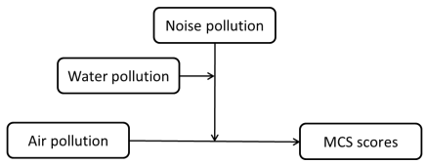
Figure 31. Conceptual diagram
Model = 3 Y = agg_ment X = air M = noise W = water
Statistical Controls:CONTROL= empreln bmi hhdnum religion alcohg smokg
Sample size 3697

**************************************************************************
Outcome: agg_ment

Model Summary
R R-sq MSE F df1 df2 p
.15 .02 86.64 6.16 13.00 3683.00 .00

Model
coeff se t p LLCI ULCI
constant 42.59 1.21 35.16 .00 40.21 44.96
noise -.50 .42 -1.17 .24 -1.33 .34
air -.51 .44 -1.14 .25 -1.38 .36
int_1 .89 .87 1.02 .31 -.82 2.60
water -.87 .46 -1.88 .06 -1.78 .04
int_2 .43 .91 .48 .63 -1.35 2.21
int_3 -1.61 1.07 -1.51 .13 -3.70 .48
int_4 4.22 1.85 2.28 .02 .59 7.86
empreln -.78 .34 -2.30 .02 -1.44 -.11
bmi .25 .05 5.33 .00 .16 .34
hhdnum -.07 .14 -.52 .60 -.35 .20
religion .51 .47 1.07 .29 -.42 1.44
alcohg .53 .37 1.44 .15 -.19 1.25
smokg 1.22 .35 3.46 .00 .53 1.92

Interactions:

int_1 air X noise
int_2 air X water
int_3 noise X water
int_4 air X noise X water

*************************************************************************

Conditional effect of X on Y at values of the moderator(s):
water noise Effect se t p LLCI ULCI
-.27 -.30 -.55 .70 -.80 .43 -1.92 .81
-.27 .70 -.78 .79 -1.00 .32 -2.33 .76
.73 -.30 -1.38 .90 -1.54 .12 -3.15 .38
.73 .70 2.60 1.24 2.10 .04 .18 5.03

Conditional effect of X*M interaction at values of W:
water Effect se t p LLCI ULCI
-.27 -.23 1.05 -.22 .82 -2.29 1.83
.73 3.99 1.53 2.61 .01 .99 6.99

**************************************************************************

Data for visualizing conditional effect of X on Y
Paste text below into a SPSS syntax window and execute to produce plot.

DATA LIST FREE/air water noise agg_ment.
BEGIN DATA.

-.29 -.27 -.30 49.17
.71 -.27 -.30 48.61
-.29 -.27 .70 49.17
.71 -.27 .70 48.38
-.29 .73 -.30 49.02
.71 .73 -.30 47.64
-.29 .73 .70 46.18
.71 .73 .70 48.79

END DATA.
GRAPH/SCATTERPLOT=air WITH agg_ment BY noise/PANEL ROWVAR=water.

* Estimates are based on setting covariates to their sample means.

******************** ANALYSIS NOTES AND WARNINGS *************************

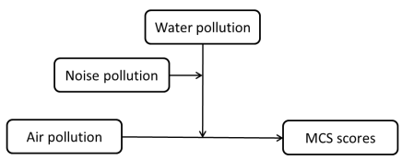
Figure 32. Conceptual diagram

Model = 3 Y = agg_ment X = air M = water W = noise
Statistical Controls:CONTROL= empreln bmi hhdnum religion alcohg smokg
Sample size 3697

**************************************************************************
Outcome: agg_ment

Model Summary
R R-sq MSE F df1 df2 p
.15 .02 86.64 6.16 13.00 3683.00 .00

Model
coeff se t p LLCI ULCI
constant 42.59 1.21 35.16 .00 40.21 44.96
water -.87 .46 -1.88 .06 -1.78 .04
air -.51 .44 -1.14 .25 -1.38 .36
int_1 .43 .91 .48 .63 -1.35 2.21
noise -.50 .42 -1.17 .24 -1.33 .34
int_2 .89 .87 1.02 .31 -.82 2.60
int_3 -1.61 1.07 -1.51 .13 -3.70 .48
int_4 4.22 1.85 2.28 .02 .59 7.86
empreln -.78 .34 -2.30 .02 -1.44 -.11
bmi .25 .05 5.33 .00 .16 .34
hhdnum -.07 .14 -.52 .60 -.35 .20
religion .51 .47 1.07 .29 -.42 1.44
alcohg .53 .37 1.44 .15 -.19 1.25
smokg 1.22 .35 3.46 .00 .53 1.92

Interactions:

int_1 air X water
int_2 air X noise
int_3 water X noise
int_4 air X water X noise

*************************************************************************

Conditional effect of X on Y at values of the moderator(s):
noise water Effect se t p LLCI ULCI
-.30 -.27 -.55 .70 -.80 .43 -1.92 .81
-.30 .73 -1.38 .90 -1.54 .12 -3.15 .38
.70 -.27 -.78 .79 -1.00 .32 -2.33 .76
.70 .73 2.60 1.24 2.10 .04 .18 5.03

Conditional effect of X*M interaction at values of W:
noise Effect se t p LLCI ULCI
-.30 -.83 1.13 -.73 .46 -3.06 1.39
.70 3.39 1.47 2.31 .02 .51 6.27

**************************************************************************

Data for visualizing conditional effect of X on Y
Paste text below into a SPSS syntax window and execute to produce plot.

DATA LIST FREE/air noise water agg_ment.
BEGIN DATA.

-.29 -.30 -.27 49.17
.71 -.30 -.27 48.61
-.29 -.30 .73 49.02
.71 -.30 .73 47.64
-.29 .70 -.27 49.17
.71 .70 -.27 48.38
-.29 .70 .73 46.18
.71 .70 .73 48.79

END DATA.
GRAPH/SCATTERPLOT=air WITH agg_ment BY water/PANEL ROWVAR=noise.

* Estimates are based on setting covariates to their sample means.

******************** ANALYSIS NOTES AND WARNINGS *************************

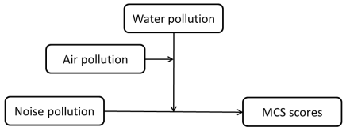
Figure 33. Conceptual diagram

Model = 3 Y = agg_ment X = noise M = water W = air
Statistical Controls:CONTROL= empreln bmi hhdnum religion alcohg smokg
Sample size 3697

**************************************************************************
Outcome: agg_ment

Model Summary
R R-sq MSE F df1 df2 p
.15 .02 86.64 6.16 13.00 3683.00 .00

Model
coeff se t p LLCI ULCI
constant 42.59 1.21 35.16 .00 40.21 44.96
water -.87 .46 -1.88 .06 -1.78 .04
noise -.50 .42 -1.17 .24 -1.33 .34
int_1 -1.61 1.07 -1.51 .13 -3.70 .48
air -.51 .44 -1.14 .25 -1.38 .36
int_2 .89 .87 1.02 .31 -.82 2.60
int_3 .43 .91 .48 .63 -1.35 2.21
int_4 4.22 1.85 2.28 .02 .59 7.86
empreln -.78 .34 -2.30 .02 -1.44 -.11
bmi .25 .05 5.33 .00 .16 .34
hhdnum -.07 .14 -.52 .60 -.35 .20
religion .51 .47 1.07 .29 -.42 1.44
alcohg .53 .37 1.44 .15 -.19 1.25
smokg 1.22 .35 3.46 .00 .53 1.92

Interactions:

int_1 noise X water
int_2 noise X air
int_3 water X air
int_4 noise X water X air

*************************************************************************

Conditional effect of X on Y at values of the moderator(s):
air water Effect se t p LLCI ULCI
-.29 -.27 .00 .54 .00 1.00 -1.05 1.05
-.29 .73 -2.84 1.31 -2.16 .03 -5.41 -.27
.71 -.27 -.23 .90 -.26 .80 -2.00 1.54
.71 .73 1.15 .79 1.46 .14 -.39 2.70

Conditional effect of X*M interaction at values of W:
air Effect se t p LLCI ULCI
-.29 -2.84 1.42 -2.00 .05 -5.62 -.06
.71 1.38 1.20 1.16 .25 -.96 3.73

**************************************************************************

Data for visualizing conditional effect of X on Y
Paste text below into a SPSS syntax window and execute to produce plot.

DATA LIST FREE/noise air water agg_ment.
BEGIN DATA.

-.30 -.29 -.27 49.17
.70 -.29 -.27 49.17
-.30 -.29 .73 49.02
.70 -.29 .73 46.18
-.30 .71 -.27 48.61
.70 .71 -.27 48.38
-.30 .71 .73 47.64
.70 .71 .73 48.79

END DATA.
GRAPH/SCATTERPLOT=noise WITH agg_ment BY water/PANEL ROWVAR=air.

* Estimates are based on setting covariates to their sample means.

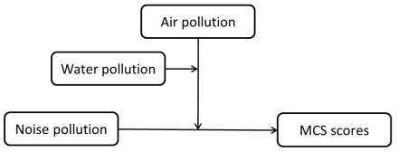
Figure 34. Conceptual diagram

Model = 3 Y = agg_ment X = noise M = air W = water
Statistical Controls:CONTROL= empreln bmi hhdnum religion alcohg smokg
Sample size 3697

**************************************************************************
Outcome: agg_ment

Model Summary
R R-sq MSE F df1 df2 p
.15 .02 86.64 6.16 13.00 3683.00 .00

Model
coeff se t p LLCI ULCI
constant 42.59 1.21 35.16 .00 40.21 44.96
air -.51 .44 -1.14 .25 -1.38 .36
noise -.50 .42 -1.17 .24 -1.33 .34
int_1 .89 .87 1.02 .31 -.82 2.60
water -.87 .46 -1.88 .06 -1.78 .04
int_2 -1.61 1.07 -1.51 .13 -3.70 .48
int_3 .43 .91 .48 .63 -1.35 2.21
int_4 4.22 1.85 2.28 .02 .59 7.86
empreln -.78 .34 -2.30 .02 -1.44 -.11
bmi .25 .05 5.33 .00 .16 .34
hhdnum -.07 .14 -.52 .60 -.35 .20
religion .51 .47 1.07 .29 -.42 1.44
alcohg .53 .37 1.44 .15 -.19 1.25
smokg 1.22 .35 3.46 .00 .53 1.92

Interactions:

int_1 noise X air
int_2 noise X water
int_3 air X water
int_4 noise X air X water

*************************************************************************

Conditional effect of X on Y at values of the moderator(s):
water air Effect se t p LLCI ULCI
-.27 -.29 .00 .54 .00 1.00 -1.05 1.05
-.27 .71 -.23 .90 -.26 .80 -2.00 1.54
.73 -.29 -2.84 1.31 -2.16 .03 -5.41 -.27
.73 .71 1.15 .79 1.46 .14 -.39 2.70

Conditional effect of X*M interaction at values of W:
water Effect se t p LLCI ULCI
-.27 -.23 1.05 -.22 .82 -2.29 1.83
.73 3.99 1.53 2.61 .01 .99 6.99

**************************************************************************

Data for visualizing conditional effect of X on Y
Paste text below into a SPSS syntax window and execute to produce plot.

DATA LIST FREE/noise water air agg_ment.
BEGIN DATA.

-.30 -.27 -.29 49.17
.70 -.27 -.29 49.17
-.30 -.27 .71 48.61
.70 -.27 .71 48.38
-.30 .73 -.29 49.02
.70 .73 -.29 46.18
-.30 .73 .71 47.64
.70 .73 .71 48.79

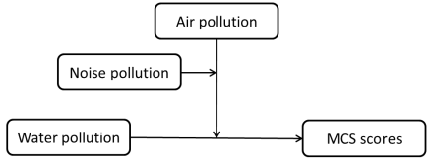
Figure 35. Conceptual diagram

Model = 3 Y = agg_ment X = water M = air W = noise
Statistical Controls:CONTROL= empreln bmi hhdnum religion alcohg smokg
Sample size 3697
**************************************************************************
Outcome: agg_ment

Model Summary
R R-sq MSE F df1 df2 p
.15 .02 86.64 6.16 13.00 3683.00 .00
Model
coeff se t p LLCI ULCI
constant 42.59 1.21 35.16 .00 40.21 44.96
air -.51 .44 -1.14 .25 -1.38 .36
water -.87 .46 -1.88 .06 -1.78 .04
int_1 .43 .91 .48 .63 -1.35 2.21
noise -.50 .42 -1.17 .24 -1.33 .34
int_2 -1.61 1.07 -1.51 .13 -3.70 .48
int_3 .89 .87 1.02 .31 -.82 2.60
int_4 4.22 1.85 2.28 .02 .59 7.86
empreln -.78 .34 -2.30 .02 -1.44 -.11
bmi .25 .05 5.33 .00 .16 .34
hhdnum -.07 .14 -.52 .60 -.35 .20
religion .51 .47 1.07 .29 -.42 1.44
alcohg .53 .37 1.44 .15 -.19 1.25
smokg 1.22 .35 3.46 .00 .53 1.92
Interactions:
int_1 water X air
int_2 water X noise
int_3 air X noise
int_4 water X air X noise
*************************************************************************
Conditional effect of X on Y at values of the moderator(s):
noise air Effect se t p LLCI ULCI
-.30 -.29 -.15 .65 -.23 .82 -1.42 1.12
-.30 .71 -.98 .93 -1.05 .29 -2.81 .85
.70 -.29 -2.99 1.26 -2.37 .02 -5.46 -.52
.70 .71 .40 .75 .54 .59 -1.07 1.88
Conditional effect of X*M interaction at values of W:
noise Effect se t p LLCI ULCI
-.30 -.83 1.13 -.73 .46 -3.06 1.39
.70 3.39 1.47 2.31 .02 .51 6.27
**************************************************************************
Data for visualizing conditional effect of X on Y
Paste text below into a SPSS syntax window and execute to produce plot.
DATA LIST FREE/water noise air agg_ment.
BEGIN DATA.

-.27 -.30 -.29 49.17
.73 -.30 -.29 49.02
-.27 -.30 .71 48.61
.73 -.30 .71 47.64
-.27 .70 -.29 49.17
.73 .70 -.29 46.18
-.27 .70 .71 48.38
.73 .70 .71 48.79

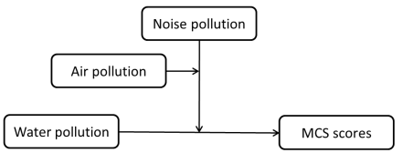
Figure 36. Conceptual diagram

Model = 3 Y = agg_ment X = water M = noise W = air
Statistical Controls:
CONTROL= empreln bmi hhdnum religion alcohg smokg
Sample size 3697
**************************************************************************
Outcome: agg_ment
Model Summary
R R-sq MSE F df1 df2 p
.15 .02 86.64 6.16 13.00 3683.00 .00
Model
coeff se t p LLCI ULCI
constant 42.59 1.21 35.16 .00 40.21 44.96
noise -.50 .42 -1.17 .24 -1.33 .34
water -.87 .46 -1.88 .06 -1.78 .04
int_1 -1.61 1.07 -1.51 .13 -3.70 .48
air -.51 .44 -1.14 .25 -1.38 .36
int_2 .43 .91 .48 .63 -1.35 2.21
int_3 .89 .87 1.02 .31 -.82 2.60
int_4 4.22 1.85 2.28 .02 .59 7.86
empreln -.78 .34 -2.30 .02 -1.44 -.11
bmi .25 .05 5.33 .00 .16 .34
hhdnum -.07 .14 -.52 .60 -.35 .20
religion .51 .47 1.07 .29 -.42 1.44
alcohg .53 .37 1.44 .15 -.19 1.25
smokg 1.22 .35 3.46 .00 .53 1.92
Interactions:
int_1 water X noise
int_2 water X air
int_3 noise X air
int_4 water X noise X air
*************************************************************************
Conditional effect of X on Y at values of the moderator(s):
air noise Effect se t p LLCI ULCI
-.29 -.30 -.15 .65 -.23 .82 -1.42 1.12
-.29 .70 -2.99 1.26 -2.37 .02 -5.46 -.52
.71 -.30 -.98 .93 -1.05 .29 -2.81 .85
.71 .70 .40 .75 .54 .59 -1.07 1.88
Conditional effect of X*M interaction at values of W:
air Effect se t p LLCI ULCI
-.29 -2.84 1.42 -2.00 .05 -5.62 -.06
.71 1.38 1.20 1.16 .25 -.96 3.73

**************************************************************************
Data for visualizing conditional effect of X on Y
Paste text below into a SPSS syntax window and execute to produce plot.
DATA LIST FREE/water air noise agg_ment.
BEGIN DATA.

-.27 -.29 -.30 49.17
.73 -.29 -.30 49.02
-.27 -.29 .70 49.17
.73 -.29 .70 46.18
-.27 .71 -.30 48.61
.73 .71 -.30 47.64
-.27 .71 .70 48.38
.73 .71 .70 48.79

